No. | INSTRUCTIONS |  | KEY POINTS / CONTACTS
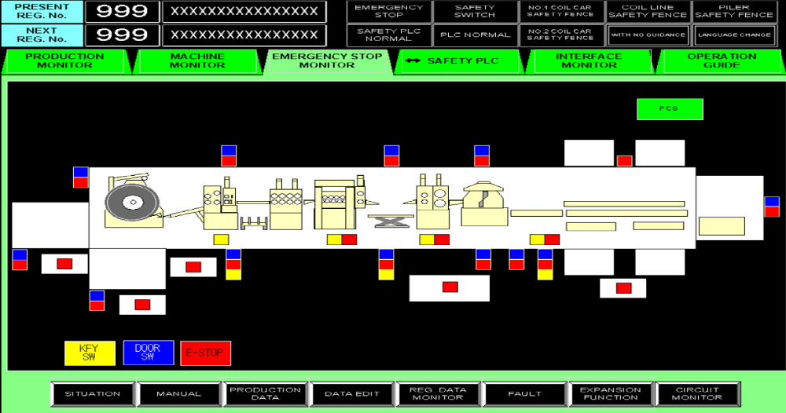  PILERS |  |  | ENSURE PERSONNAL PROTECTIVE EQUIPMENT (PPE) IS WORN IN THIS AREA: -  1. HARD HAT  2. STEEL CAP SHOES / BOOTS  PILER  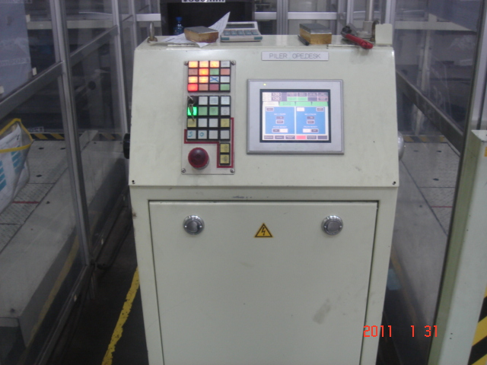
1 | 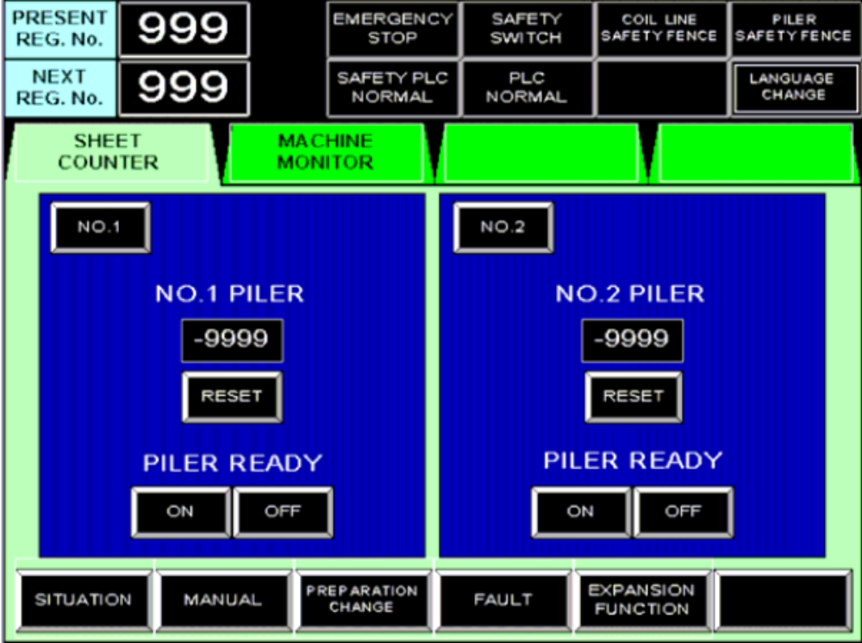 |  | If No fault conditions are present the Master On indication lamp will be ON.
2 | For Any manual operation the manual button must be selected on the operator screen |  | This display can be found on the Piler Operator station
3 | 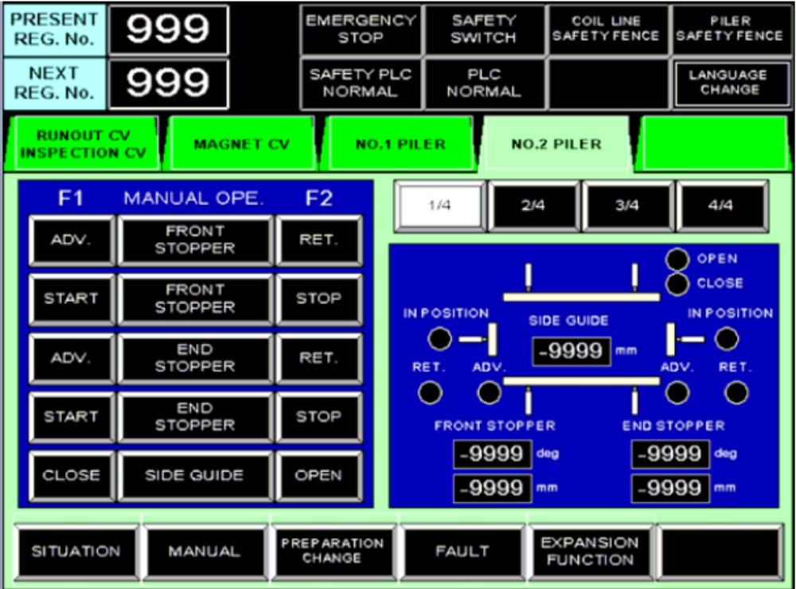 |  | There can only be one manual operation selected at a time.  This will prevent any damage to equipment.  The current display show NO.2 Piler  Page1/4
4 | A Select End Stopper operation switch. The switch will turn white when selected.  B After selecting the End Stopper operation button the F1 push button can be pushed to move the end stopper forward.  C To reverse the End stopper the F2 push button key must be used.  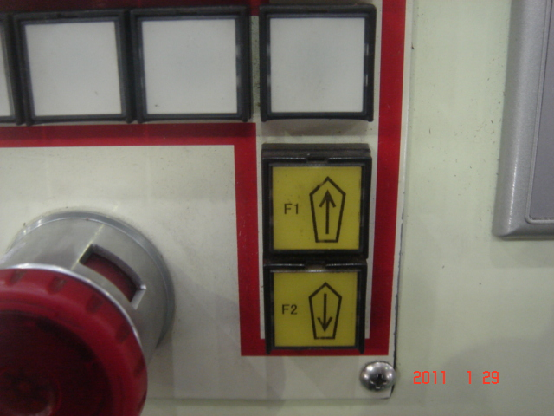 |   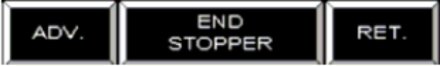    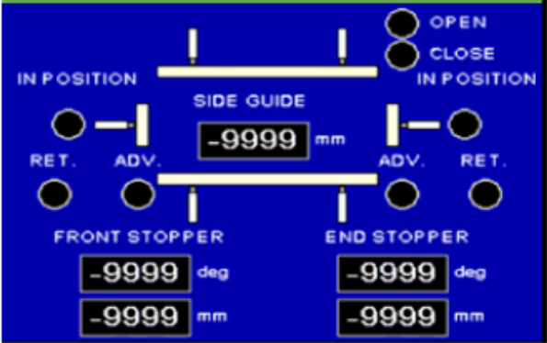 | 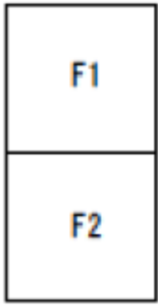  Note:  During the ADV and RET operation the ADV or RET indication will flash.  When the front stopper is fully ADV or fully RET the indication will be continuous.

Prepared by: D.Botha

